CSC3231 Coursework

By Yuchen Yin

Student ID: 210155729

In this planet you will see:

**The ridiculously big sun**

Simulation day night switch, Self-illumination and halo.

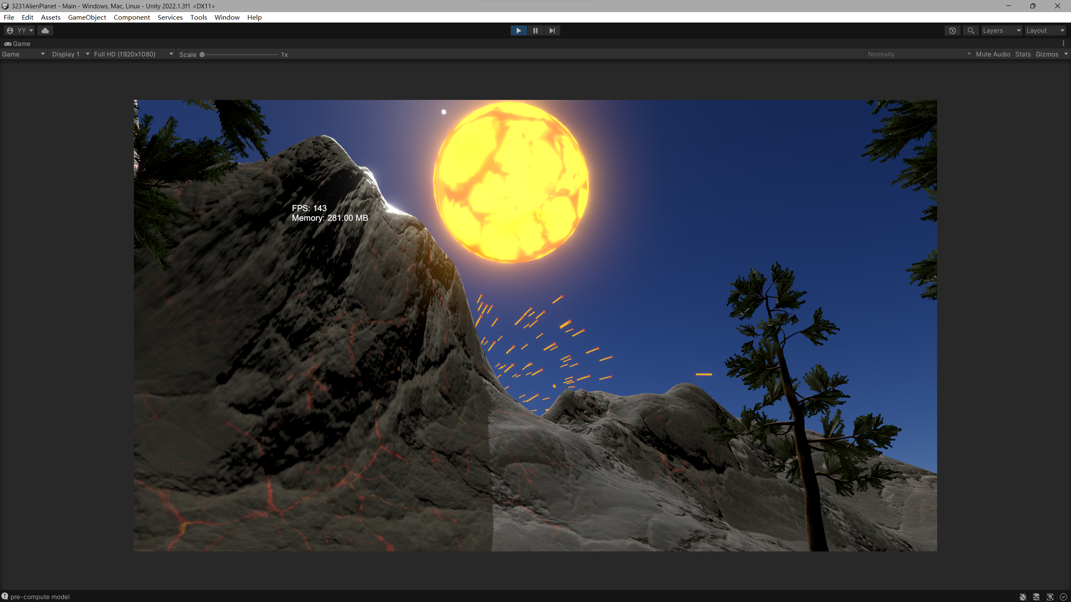

**Amazing moving space battleships and weird volumetric beams**

Achieved volumetric light and programming dynamic beam strafe。

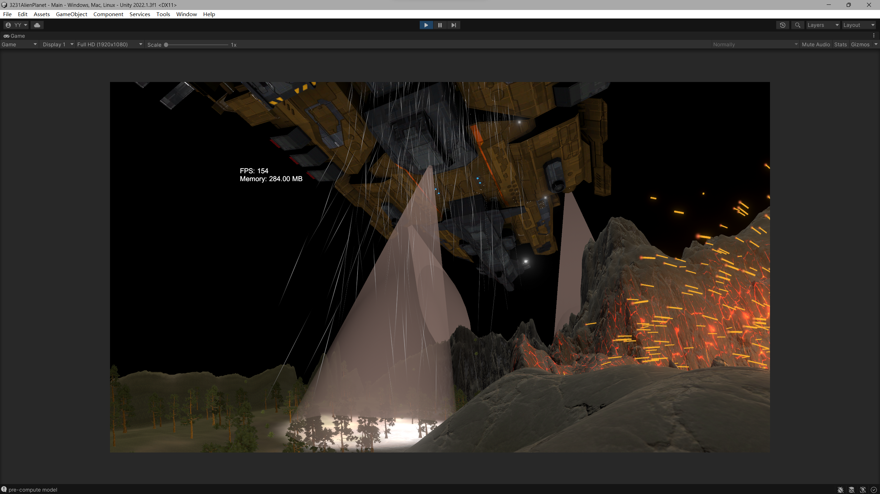

**Simulated water and surrounding luminous body**

Rippled and reflective real liked water, light bodies that move around their parent object.

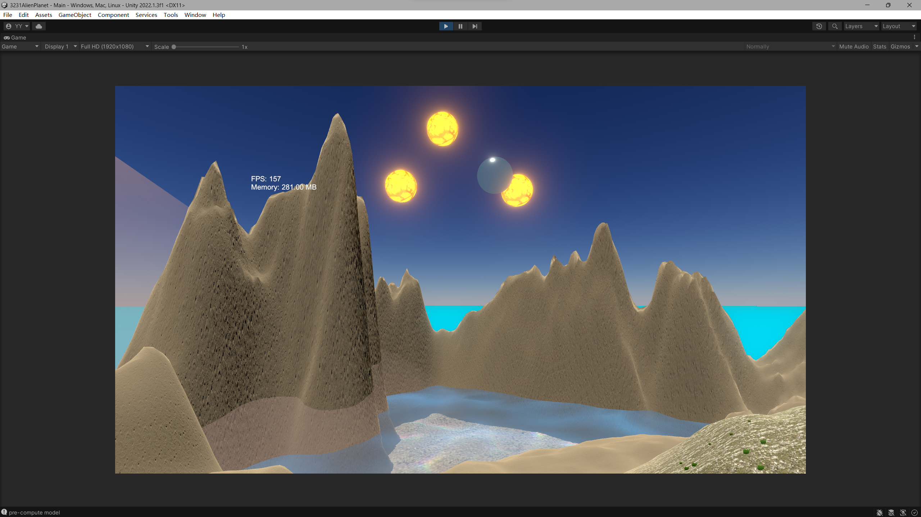

**Rain weather and volcanic splash**

Particle system simulation, Ambient light exposure and well-prepared light scenes.

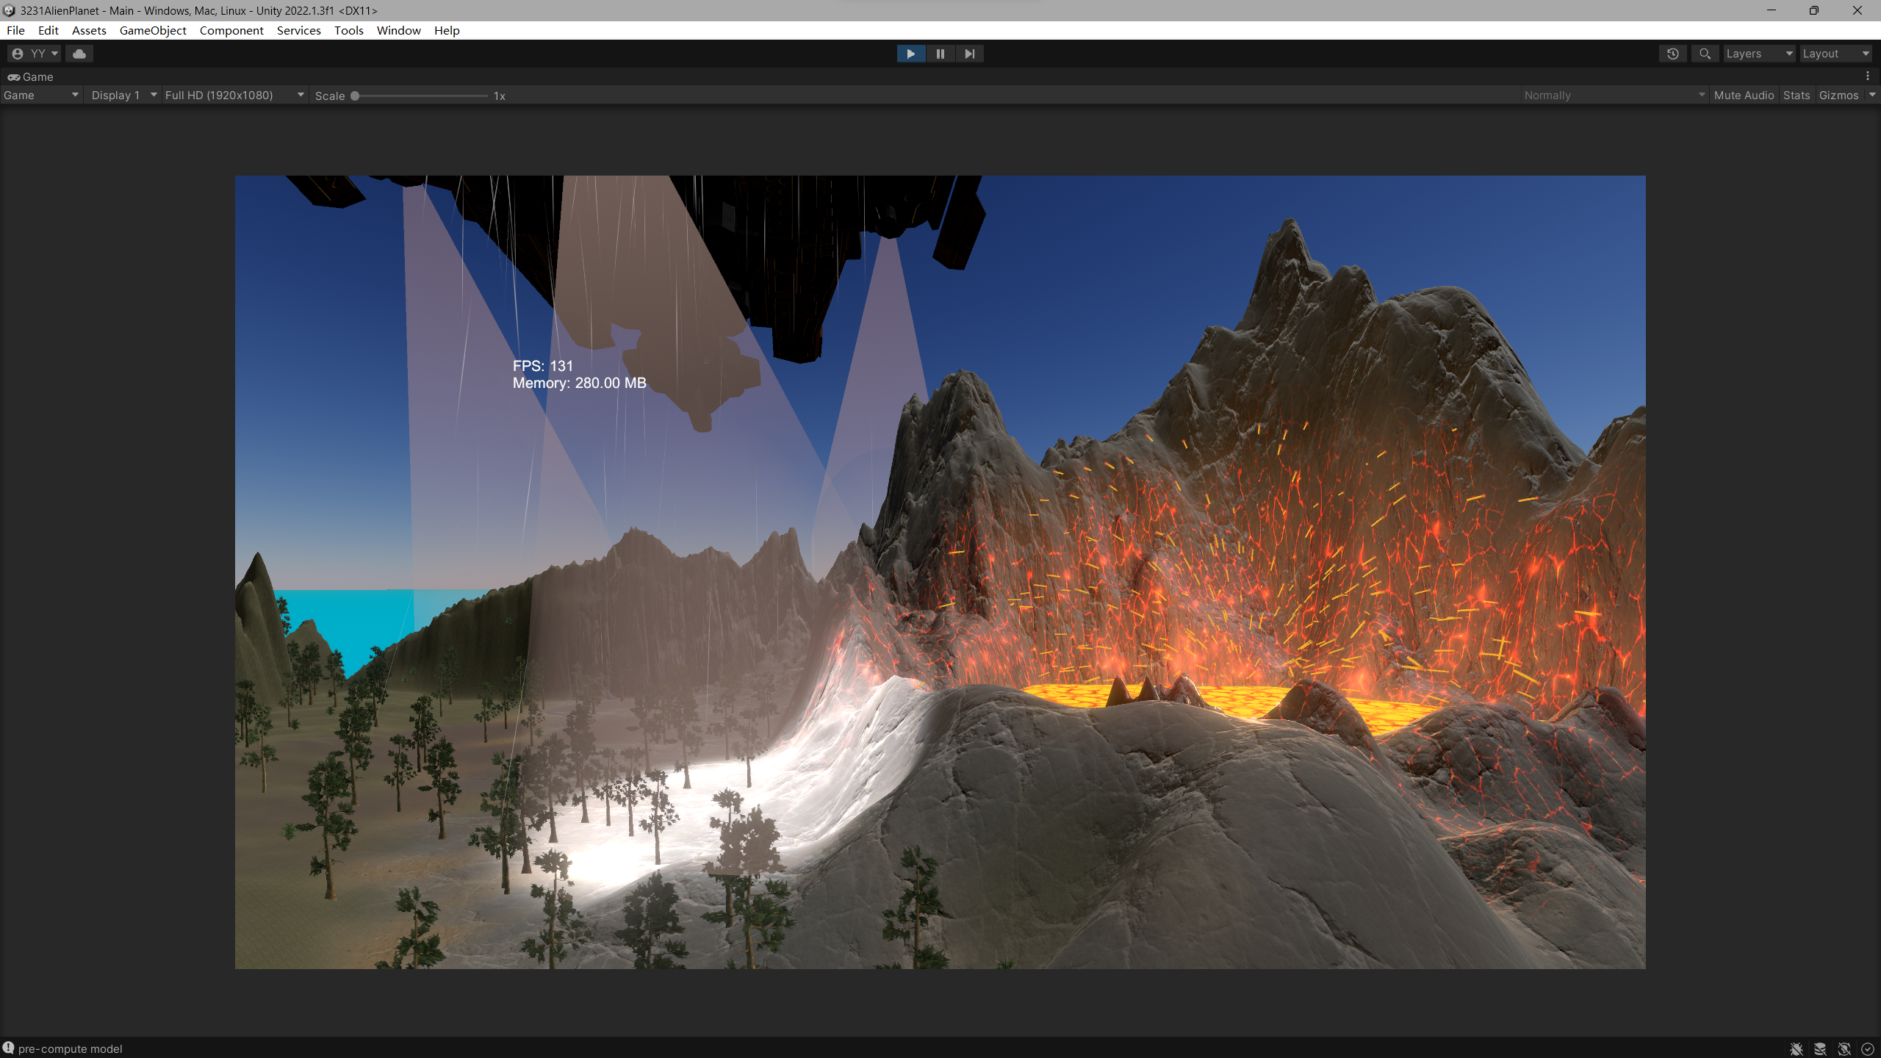

Implemented character navigation camera, FPS and current memory used. Details of the reference can be found in the reference document.

Video Link: <https://youtu.be/rZBAQH8DAYI>